/ PRESS INFORMATION // MAY 2024

**GrindingHub 2024: The future of deburring**

**Laupheim, May 15th, 2024 - Many machining processes produce unwanted burrs and protruding fibres on components and to remove these automatically and in a contact-free manner, ultraTEC innovation GmbH has developed an innovative process. The technology company based in southwestern Germany uses the power of ultrasonic to deburr components. The technology guides components along an ultrasonic horn in a water basin, whose generated vibrations cause the burrs and fibres to break-off in an energy-efficient manner.**

It all began five years ago as a start-up in the Swabian town of Laupheim. Dieter Münz, founder and Managing Director of ultraTEC innovation GmbH, is shaking up the deburring market with his new ultrasonic deburring technology. A successful youth research project paired with technical finesse and a lot of will serve as the basis for the young company. Today, ultraTEC has many different ultrasonic deburring machines in its portfolio and can respond flexibly to customer requirements. In addition, ultraTEC has been part of the internationally active Vollmer Group from Biberach an der Riß since July 2022 and will also be able to serve international markets in the future.

Non-contact ultrasonic deburring with the patented ultrasonic horn is the foundation of ultraTEC. Whether drilling, milling, turning or grinding, as soon as machining takes place, unwanted burrs and fibers are created on edges, cross bores or surfaces. In addition to common metals, ultraTEC systems can also be used to deburr components made of various titanium and nickel alloys through to fiber-reinforced plastics.

**Ultrasonic deburring with high-frequency sonotrodes**

In the process developed by ultraTEC, components are guided to the high-frequency ultrasonic horn in a process water basin. Stimulated by a generator, it oscillates back and forth over 0.1 millimetres 20,000 times a second. These vibrations move burrs and fibers back and forth until they break off with a sharp edge in a reliable process. Users can easily dispose of the process water without further treatment.

**New generation in the A-series**

It all started at with the A series. Back then, the A15 was the first ultrasonic deburring machine to be launched on the market. This was later replaced by the more flexible A25, which has been continuously optimized in recent years. A new generation of machines is now ready and will be presented to the international visitors for the first time at GrindingHUB. The new A25 S is already visually very different from the previous A25. This is because ultraTEC is moving away from a machine housing made of aluminum profiles to a solid steel frame with the new “Generation S”. This results in significantly greater stability and an even more precise deburring process. But there are also some new features in the machine. In addition to optimized part drying, the process water basin has been completely redesigned. This enables even more flexible processing of a wide variety of components with the ultrasonic horn. “We are delighted to finally present our new A25 S and thus the new ‘Generation S’ to the international audience at GrindingHub and to discuss innovative ultrasonic deburring with visitors,” says Thomas Benzing, Head of Sales at ultraTEC.

3.295 Characters (with spaces)

**Press photos**

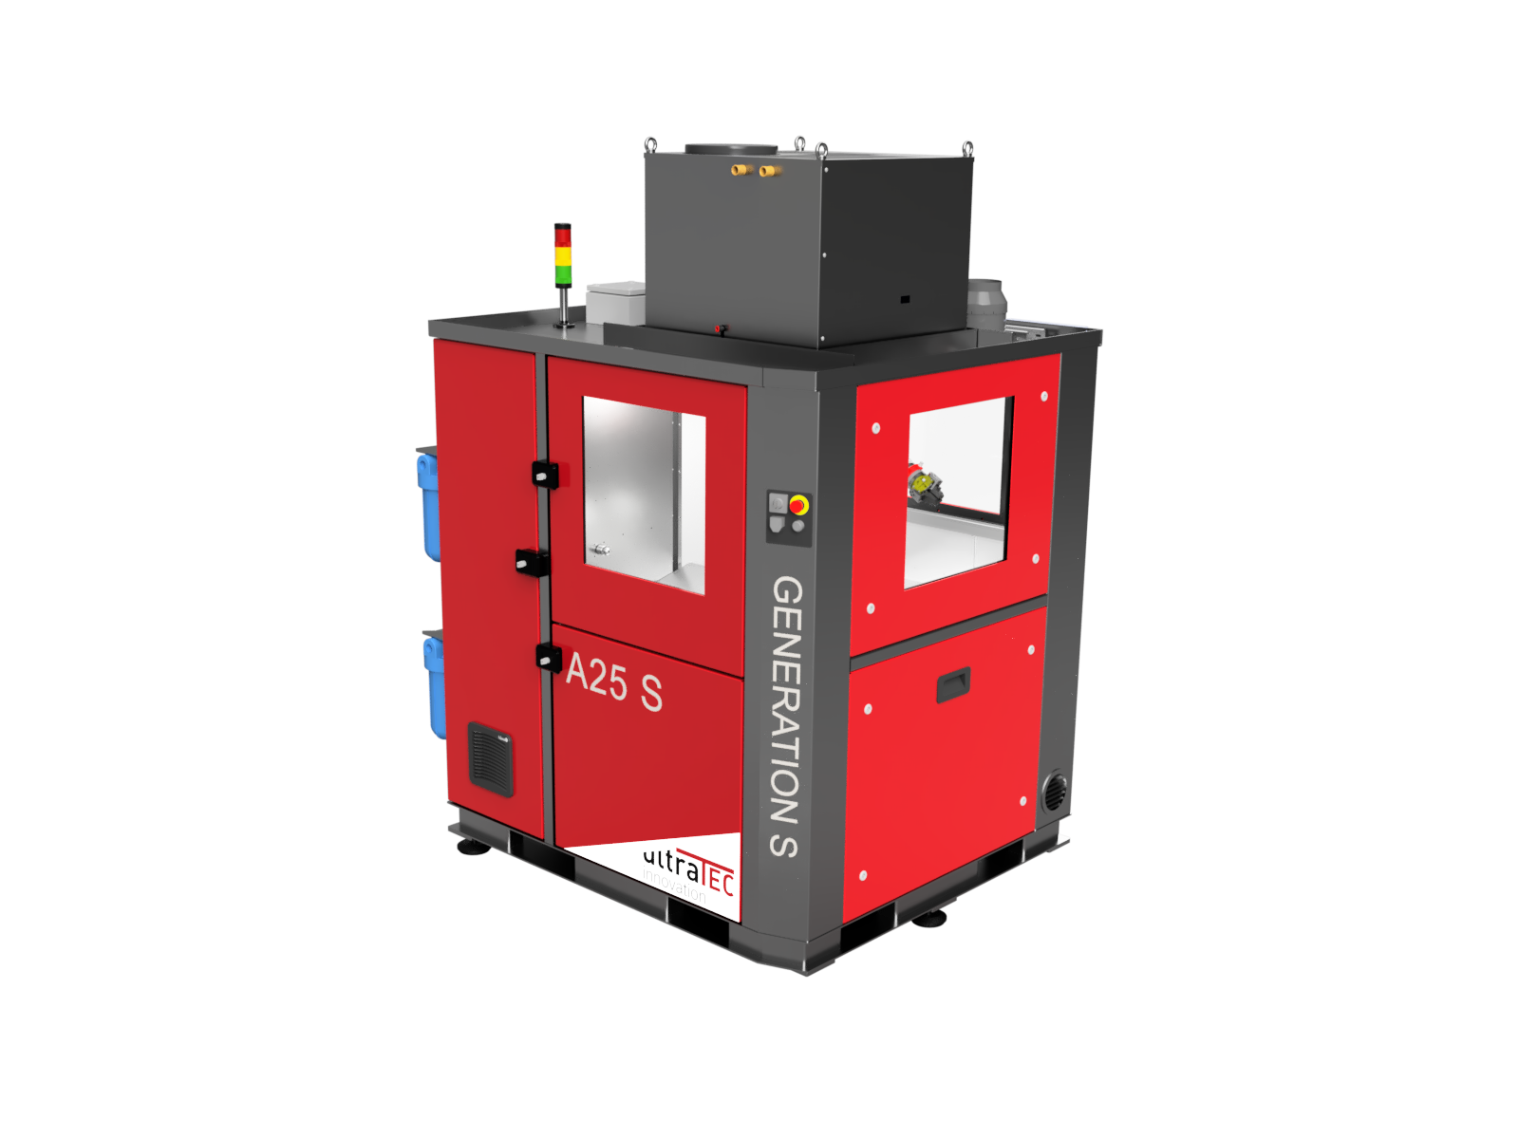

**Caption:** The A25 S ultrasonic deburring machine from ultraTEC innovation can be used to remove interfering burrs and fibers from machined components.

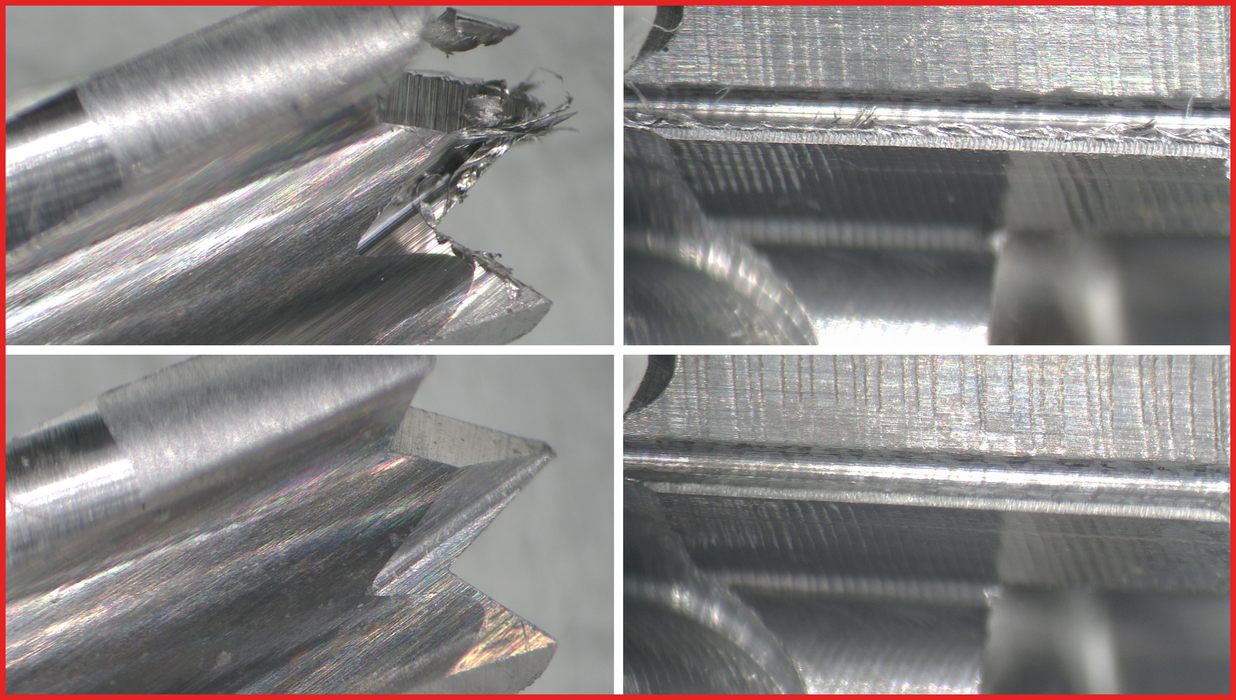

**Caption:** Before and after: Selective deburring for optimum results without removing material

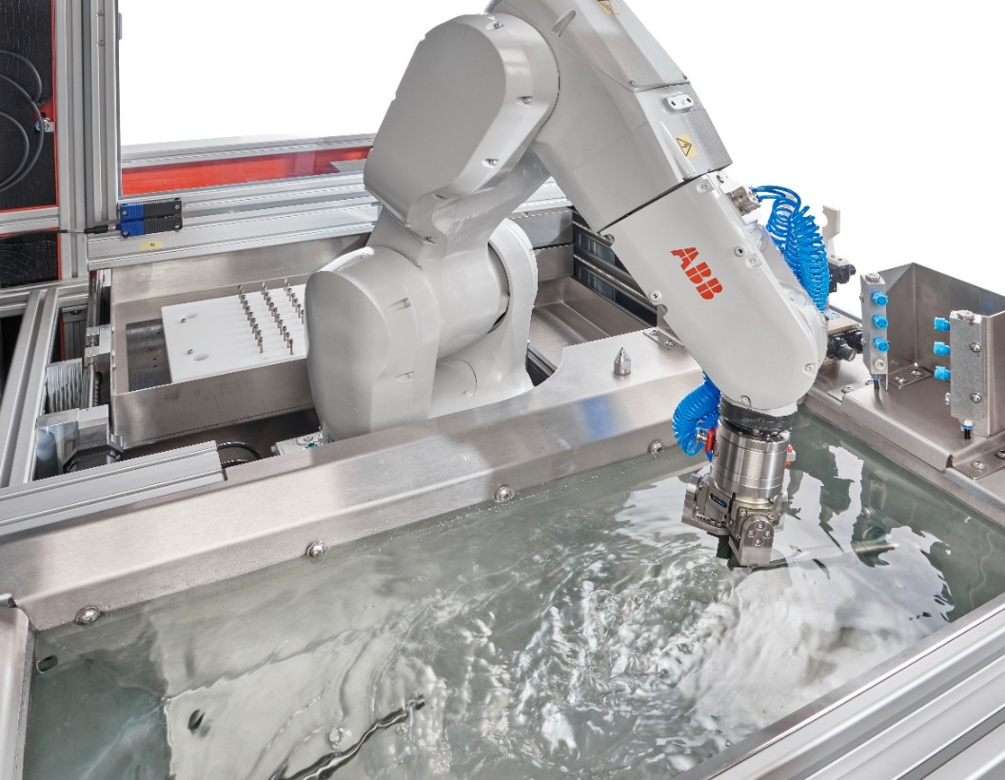

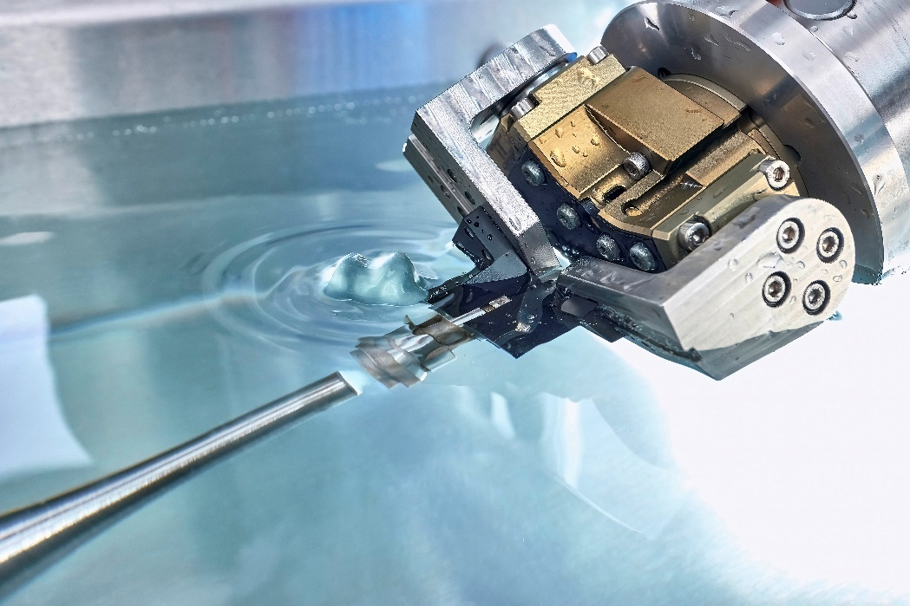

**Caption:** An industrial robot is used to guide the components to the ultrasonic horns in a defined position.

Further information is available at:

[www.ultratec-anlagen.de/kontakt/presse](http://www.ultratec-anlagen.de/kontakt/presse)

Video - ultraTEC - Deburring in 100 seconds:

<https://www.youtube.com/watch?v=5RAbQMOY4TY>

Also visit us on LinkedIn:  
[www.linkedin.com/company/ultratec-innovation](http://www.linkedin.com/company/ultratec-innovation)

Contacts for journalists

**VOLLMER WERKE Maschinenfabrik GmbH**

Ingo Wolf

Head of Marketing Services

Telefon: +49 (0)7351/571-277

E-Mail: [i.wolf@vollmer-group.com](mailto:i.wolf@vollmer-group.com)

**ultraTEC innovation GmbH**

Patrizia Faßnacht

Marketing

Telefon: +49 (0)7392/9286-266

E-Mail: patrizia.fassnacht@ultratec-innovation.de

The images and image texts provided by ultraTEC may only be used in connection with editorial reporting on ultraTEC. Use is free of charge if the source is cited as “ultraTEC innovation GmbH, Uhlmannstraße 46, 88471 Laupheim”

Graphical changes are not permitted. Please inform us in case of use.